**Model Development Phase Template**

|  |  |
| --- | --- |
| Date | 9 JULY 2024 |
| Team ID | 739661 |
| Project Title | Anemiasense: Leveraging Machine Learning For Precise Anemia Recognitions |
| Maximum Marks | 4 Marks |

**Initial Model Training Code, Model Validation and Evaluation Report**

The initial model training code will be showcased in the future through a screenshot. The model validation and evaluation report will include classification reports, accuracy, and confusion matrices for multiple models, presented through respective screenshots.

**Initial Model Training Code:**

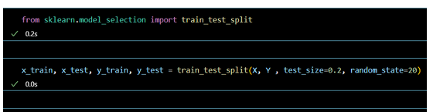

**Model Validation and Evaluation Report:**

|  |  |  |  |
| --- | --- | --- | --- |
| **Model** | **Classification Report** | | **Accuracy** |
| **Logistic Regression Model** |  | | 0.991 |
| **Random forest model** |  | | 1.0 |
| **Decision**  **Tree Model** |  | | 1.0 |
| **Gaussian Navies Bayes** | |  | 0.979 |
| **Gradient Boosting Classifier** | |  | 1.0 |